Journey of Food – Bread

**Mouth and Oesophagus**

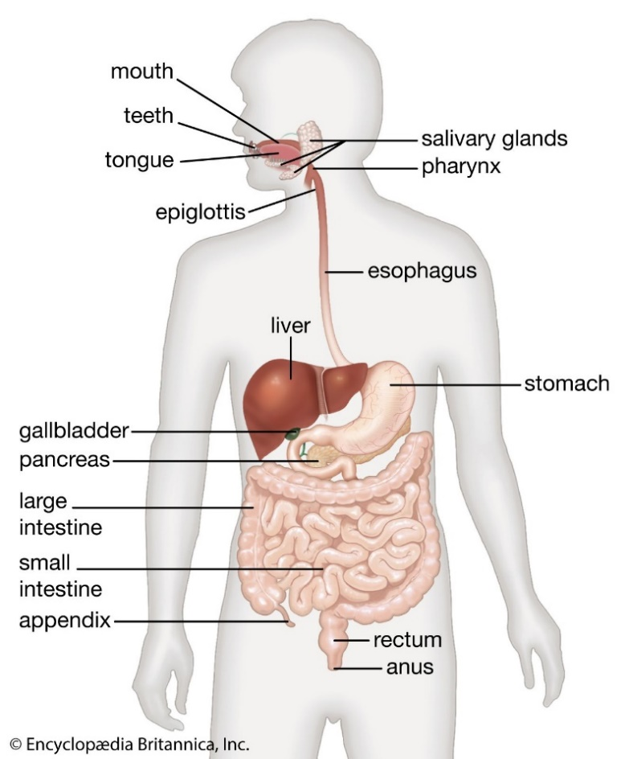As the bread enters the mouth, the teeth and tongue help with the mechanical digestion. The teeth break down the food for swallowing. The incisors (at the middle front of the upper and lower jaw) help tear a piece of bread. The molars (at the back of the mouth) help grind and chew the food into a paste for an easy swallow.

<file:///C:/Users/charm/AppData/Local/Temp/OneNote/16.0/Exported/%7B14DE9381-34F7-4193-9898-DBCB08C9BD86%7D/NT/0/Chapter%209%20The%20digestive%20system.pdf>

While the bread is being chewed, the salivary glands from the back of the mouth lubricate the mouth with saliva, and the digestion starts. The amylase begins to break down the carbohydrate molecules of the bread into smaller and simpler sugars, which is the chemical digestion.

Before swallowing the bread, the epiglottis (the flap at the back of the tongue) prevents the food from entering the trachea. The epiglottis separates the trachea and the oesophagus; the epiglottis opens when the person breathes, and it closes when the person swallows. The oesophagus is a muscular tube that connects with the stomach.

<https://www.britannica.com/science/human-digestive-system>

The oesophagus contracts, forcing the bread down through the oesophagus to the stomach and the cardiac sphincter (a thick ring of muscle) close the oesophagus to prevent the bread going back into the oesophagus, otherwise it will cause a heartburn—when the bread in the stomach goes back into the oesophagus.

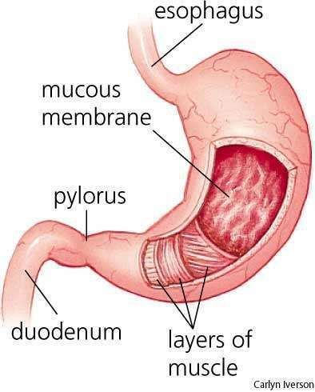**Stomach**

When the bread enters the stomach, it releases gastric juices from the gastric glands (hydrochloric acid, mucus, and digestive enzymes) to help digest it. The hydrochloric acid in the gastric juice breaks the food down as the enzymes split the proteins up. The mucus lubricates the stomach to protect it from the acids that are released into the stomach, which has a pH of 1.5-2.0. With the bicarbonate, it ensures that the stomach wall is not damaged by the hydrochloric acid. The acidic gastric juices, which are digestive enzymes also kills bacteria in the bread.

<https://www.overdriveonline.com/life/article/14885315/ulcers-when-to-say-when>

The smooth muscle in the stomach can contract in numerous ways to churn the bread and combine with gastric juice to further digest before entering the small intestines, and the enzymes will further help digest it. Amylase (an enzyme) is released into the stomach and helps break down the sugars of the carbohydrate. The bread turns into a chyme (a thick mixture) by the contractions of the stomach.

**Small Intestine**

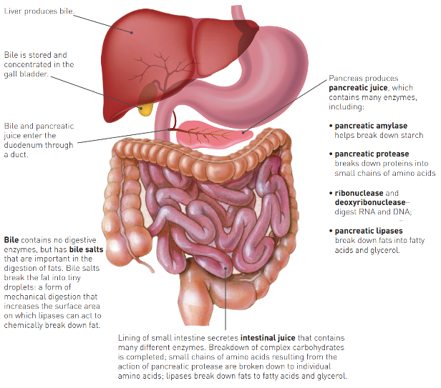Breakdown

The first part of the small intestines (the duodenum), the pancreas secretes pancreatic juices—pancreatic amylase—to further break down the starches in the bread into glucose and other simpler sugars, as well as to neutralise the acids that came with the material from the stomach.

The liver produces bile; however, it is not a digestive enzyme. Although the bile salts are important as they combine the fat, which splits into droplets; and bile is stored in the gall bladder where it releases bile into the small intestine to help break the fats down within the bread.

<file:///C:/Users/charm/AppData/Local/Temp/OneNote/16.0/Exported/%7B14DE9381-34F7-4193-9898-DBCB08C9BD86%7D/NT/0/Chapter%209%20The%20digestive%20system.pdf>

Absorption

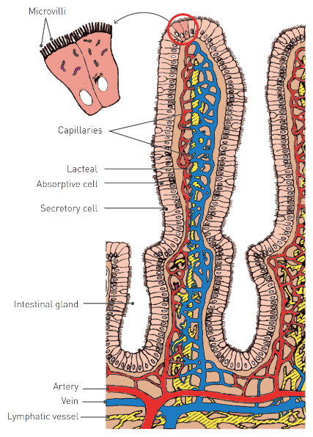In the small intestine, there are millions of finger-like projections called villi on its surface that absorbs nutrients from the chyme. Each villus is approximately 1mm and covered by a single layer of cells with microvilli on the surface to increase surface area to facilitate the absorption of vitamins, minerals, and water into the bloodstream.

Simple diffusion occurs for absorption as there is a higher concentration of materials in the small intestines than the cell lining. Active transport can also happen as the energy is being used by the villi to absorb the nutrients (going against the concentration gradient).

<file:///C:/Users/charm/AppData/Local/Temp/OneNote/16.0/Exported/%7B14DE9381-34F7-4193-9898-DBCB08C9BD86%7D/NT/0/Chapter%209%20The%20digestive%20system.pdf>

Simple sugars, amino acids, water, and water-soluble minerals are absorbed into the blood capillaries from the walls of the villi as they are carried to the liver to be further digestion or remain in the blood for other cells to absorb.

**Material breakdown and use**

Bread is rich with complex carbohydrates, so pancreatic amylase is secreted from the pancreas to break down the chyme to dextrin and maltose, which then the small intestines will start to make lactase, sucrase, and maltase to help further breakdown the sugars into monosaccharides (simple sugars). These sugars will get absorbed into the small intestine, into the liver to be processed more and be stored as glycogen while glucose goes to the rest of the body to be used as energy.

The proteins are broken down by pancreatic protease into small chains of amino acids which the body uses it to build and repair bones and muscles, make hormones and enzymes, and can also be used for energy.

Fats are broken down into fatty acids and glycerol by the pancreatic lipase which then gets absorbed by the villi and recombine into fats and enters the lacteals where the body uses the fat to insulate, protect vital organs, and store energy.

**Large Intestine**

As the chyme enters the large intestine (the colon) from the small intestine (through the caecum), the large intestine quickly absorbs the water from the bread. The chyme pass through the large intestine quite slowly where water is mostly absorbed, making the contents more solid. There are no villi and digestive juices secreted in the large intestine, however the lining produces a large amount of mucus.

<https://sites.google.com/a/mtlstudents.net/wallace-davis-digestive/home/large-intestine/cecum?tmpl=%2Fsystem%2Fapp%2Ftemplates%2Fprint%2F&showPrintDialog=1>

The remaining organic compounds are broken down by the bacteria in the large intestine, however many carbohydrates containing fibre cannot be digested by the body. Mineral nutrients and vitamins that have been produced by bacteria are absorbed through the walls into the blood.

**Elimination and Faeces**

Faeces is the semi-solid material left after the absorption of water and bacterial action. Faeces contain water, undigested food, bacteria, bile pigments (hence the colour), and the remains of cells.

The last part of the large intestine is the rectum where faeces is stored by the peristalsis that pushed it into the rectum. As the rectum wall stretch, defaecation happens—a trigger to respond, so the faeces can be passed out by the relaxation of the muscles around the anus.

The external opening at the end of the rectum is known as the anus, and around it is a circular muscle called the anal sphincter where the faeces is expelled from the rectum via the anus.

**References**

Website

Britannica. (2019). Microvilli | anatomy | Britannica. In *Encyclopædia Britannica*. Retrieved from <https://www.britannica.com/science/microvilli>

Kunz, K. (2016, November 1). Bread Digestion. Retrieved from prezi.com website: https://prezi.com/fz6f4nhysduz/bread-digestion/

Marcin, A. (2018). Carbohydrate Digestion: Absorption, Enzymes, Process, and More. Retrieved from Healthline website: https://www.healthline.com/health/carbohydrate-digestion#digestion-process

NCBI. (2016, August 21). How does the stomach work? Retrieved from Nih.gov website: <https://www.ncbi.nlm.nih.gov/books/NBK279304/>

University Hospitals. (2023). The Digestive Process: Digestion Begins in the Mouth | University Hospitals. Retrieved from www.uhhospitals.org website: https://www.uhhospitals.org/health-information/health-and-wellness-library/article/adult-diseases-and-conditions-v1/the-digestive-process-digestion-begins-in-the-mouth

Book

Newton, T. J., & Joyce, A. (2014). *Human perspectives units 1 & 2 : for the ATAR course* (7th ed., pp. 111–116). South Melbourne, Vic. Cengage Learning Australia.